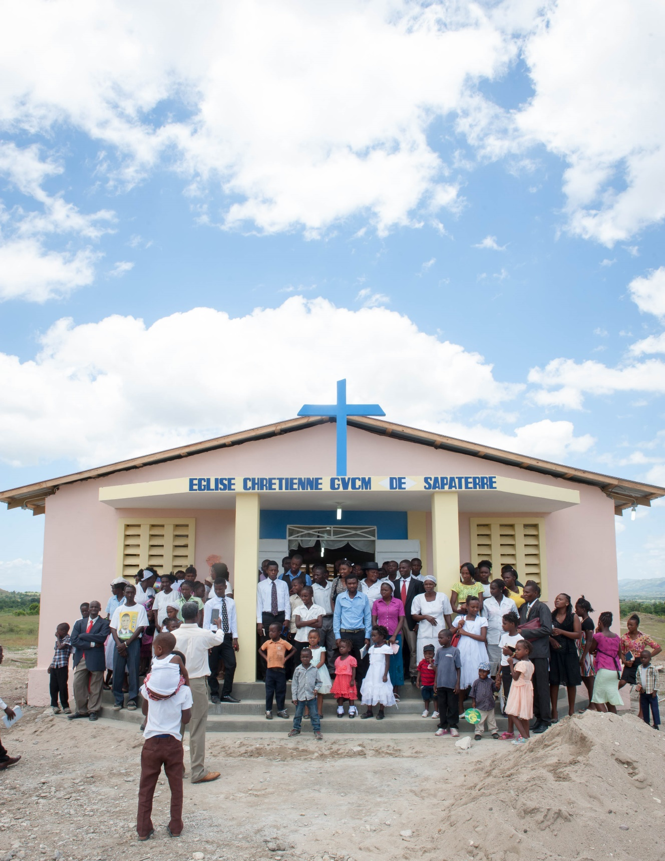
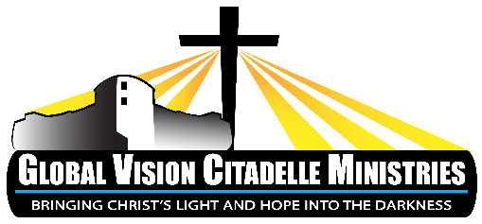
Short-Term Mission Trip Manual

Table of Contents

About Us 3
Welcome! 3
Why the name ‘Global Vision Citadelle Ministries’? 3
GVCM Mission Statement 4
About Haiti 5
Preparing for Your Trip 7
Support Raising 7
Packing 9
Dress Code 10
Medications & Vaccines 10
Passport & Visa 11
The Trip 11
Arriving in Haiti 11
Cultural Guidelines 12
General Guidelines 12
Tips and Helpful Information 13
After the Trip
Child Sponsorship
Church Visits

Global Vision Citadelle Ministries, Inc

ADDRESS
-All God’s Children Orphanage-
Route natnl #3
Route Vision Globale
imp. Five Oaks
Ledier, Haiti

-Florida Office -
683 SW Sea Holly Ter.
Port Saint Lucie, FL 34984

-Mailing Address -
PO BOX 880817
Port St Lucie, FL 34988

GENERAL CONTACT INFO
Office: 913-422-5907
www.gvcm.org
info@gvcm.org

STAFF CONTACT

Yves Prophete
Executive Director
Phone: 001-772-812-9228
Email: yves@gvcm.org

UNITED STATES

Sarah Bowers:
Operations Manager
Phone: 001-651-324-3108
Email: sarah@gvcm.org

Stephanie Stumbaugh
Administrative Admin
Phone: 001-772-971-8300
Email: stephanie@gvcm.org

HAITI

Jean Balthazar
Mission Team Support
Phone: 011-509-461-802-52
Email: matthias@gvcm.org

ABOUT US

Welcome!!

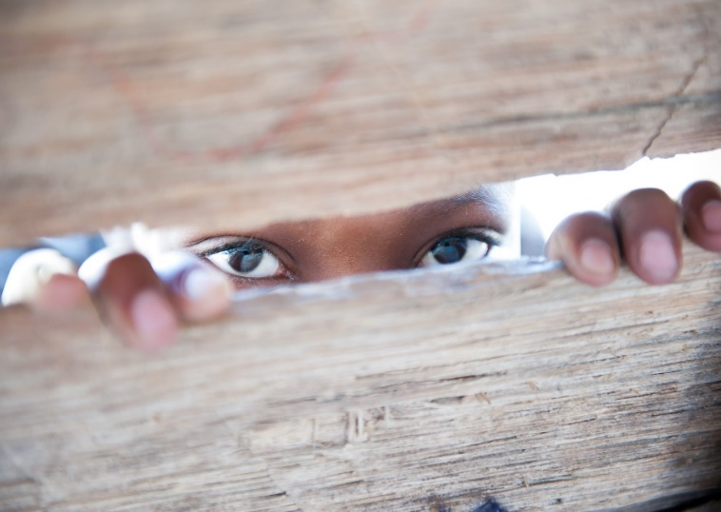
GVCM is delighted you are considering a short-term mission trip with us.

This manual will help you prepare you for your trip to Haiti.

Please read it carefully.

It is full of information that you will need to know about the mission and what to expect on your trip.

Those who have had the opportunity to minister in Haiti always find it to be a positive experience that is treasured for a lifetime.

We are a young mission and Haiti is a third world country in every sense of the term. On some trips, showers and electricity are a common occurrence. On other trips, you sleep in tents and navigate some interesting ‘toilet facilities’ in the dark. Some roads we travel are smooth; others are an exhilarating four-wheeling type of adventure (or grueling, terrifying nightmare, depending on your perspective!). Some days are hot, and some days are really hot.

We want to help you confirm that Haiti is the place where you should be serving. It is not for everyone. Our desire is to help you determine if ministry in Haiti is a good ‘fit’ for you as you read through this manual and application process. The background check, the personal testimony, and pastor’s reference are all part of that.

For your part, we invite you to ask us questions and be up-to-date on developments in Haiti (maybe even picking up a book or two, or searching the web) to familiarize yourself with your brothers’ world. We hope that this is just the beginning of a relationship that will have lasting and eternal consequence.

May God allow us to see this partnership to fruition; as it is only with His help that we can hope to make a lasting difference in Haiti and in our own lives.

Why the name ‘Global Vision Citadelle Ministries’?

Global Vision Citadelle Ministries is more than a name, it is our purpose statement.

Global Vision: With a vision greater than our earthly eyes can behold, we hope to impact the overall concern for the whole person: spirit, soul, and body.

Citadelle: Symbolic of that landmark which is a focal point of our nation’s highest aspirations for freedom.

Ministries: Reminding us to mirror such a dream with the true freedom that only Christ provides. Is there hope? Yes, in Jesus Christ’s name!

GVCM Mission Statement

We bring the hope and light of Christ into the darkest places of Haiti.

In Acts 2 we see the impact of a Spirit-driven local church. A community of people growing in the knowledge of the Word, supporting one another in fellowship and prayer; sharing their lives with one another.

When believers come together, God is there. Where the power of God is, you will see the shackles of evil fall to the ground.

Haiti is a country that has been enslaved by the grips of evil for centuries; generations worshiping Satan and rebuking God. We are called as the body of Christ to follow the example of Jesus as He proclaimed Isaiah 61 over His ministry – setting captives free, binding up the brokenhearted, and release from darkness for the prisoners, to proclaim the year of the LORD's favor and the day of vengeance of our God, to comfort all who mourn.

It is through supporting the many facets of the local church that we hope to show light across the beautiful countryside of Haiti to bring the redeeming power of Christ’s blood shed for all, and in doing so, hasten the return of Christ.
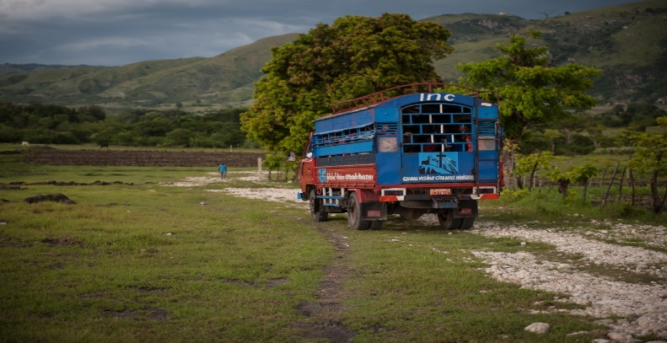

About Haiti

History
- Originally inhabited by the indigenous Taino people, the island of Hispaniola was discovered by Christopher Columbus in 1492 (thinking it was India or Asia), who claimed the island for Spain.
- As the ‘gateway to the Caribbean’, Hispaniola became a haven for pirates during the early colonial period. During this time, European nations were competing for control of the Caribbean, and eventually France took control of the western part of the island, now known as Haiti.
- Sugar was a lucrative commodity crop during the 18th century, and to develop sugar cane plantations, the French imported thousands of slaves from Africa, and was known as the most brutally efficient slave colony of the Caribbean - one third of African slaves did not survive beyond the first couple years of arrival.
- Inspired by the French Revolution of 1789, the slaves started pressing for freedom and civil rights, which culminated in the beginning of a revolt in 1791, led by the former slave Toussaint Loverture, whose military genius transformed an entire society of slaves into an independent nation.
- Independence was decreed on January 1st, 1804.
- Haiti has been the only nation in the world established as a result of a successful slave revolt, and the first nation in Latin America and the Caribbean successful in a war of independence against a European colonial power.
- The largest fortress in the Americas, the Citadelle Laferriere, was built by former slave Henri Christophe, the first King of Haiti, in order to withstand potential retaliatory European attacks. It is, to this day, a symbol of national pride, aspiration, and freedom to the Haitian people.
- Sadly, most of Haiti’s relatively short political history has been a story of an almost un-ending succession of leadership characterized by terror, corruption, and human rights abuses, with the last coup d’état as recent as 2004. Since the earthquake in 2010 and the election of Rene Preval, then Michel Martelly in 2011, there has been relative stability in the political realm.

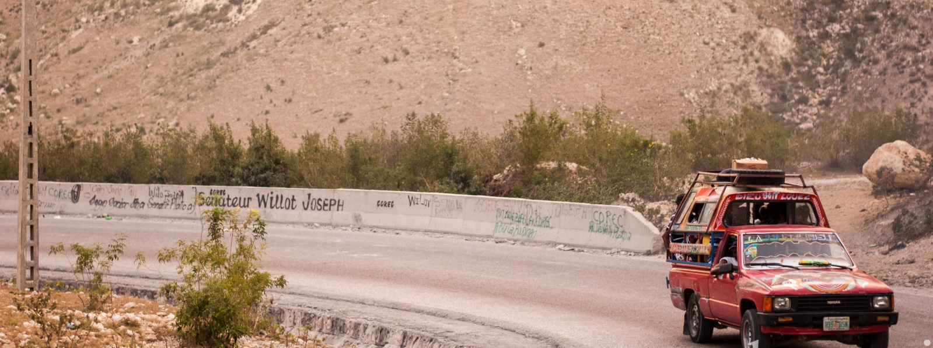

More about Haiti

Religion
- Precise numbers are unavailable, but it is estimated that 80% are Roman Catholic, 16% Protestant, and 4% other religions. Voodoo, derived in part from traditional West African beliefs, is practiced alongside Christianity by a large segment of the population.
Language
- The two official languages of Haiti are French and Haitian Creole. French is the principle written and administratively authorized language, is the medium of instruction in most schools, and is spoken by 40% of Haitians. While 40% of the population can speak French as a 2nd language, Creole is spoken by virtually the entire population of Haiti. Its vocabulary is 90% derived from French, but its grammar and influences are from some West African, Taino, Spanish, and Portuguese languages.

Economics
- The World Factbook reports a shortage of skilled labor, widespread unemployment and underemployment, saying “more than two-thirds of the labor force does not have formal jobs.”
- 80% live below the poverty line, with three-quarters of the population living on $2 or less per day. The richest 1% owns nearly half of Haiti’s wealth.
- Haiti is the poorest country in the Western hemisphere

Health
- There is only 1 doctor per 4,000 people (the ratio is much worse in the remote rural areas), and most Haitians have no transportation or access to a hospital
- 90% of Haitian children suffer from waterborne diseases and intestinal parasites
- Half of all Haitian children are undersized because of malnutrition
- Unsafe water along with inadequate housing and unsanitary living conditions contributes to a high incidence of infectious diseases
- Common causes of death are diarrheal and respiratory illnesses
- The infant mortality rate is 55 deaths per 1000 live births
- Life expectancy is 62.7 years

Geography and population
- Haiti occupies the western part of the island of Hispaniola, which it shares with the Dominican Republic.
- It is the most mountainous nation in the Caribbean, with its highest point being Mt. Pic la Selle at 8793 ft.
- Haiti is the 3rd largest Caribbean nation with 10,714 sq. miles, which is about the size of Maryland.
- Haiti is the 2nd most populated Caribbean nation with an estimated population of 10.7 million, 2.7 million of which live in the greater Port-au-Prince area.

PREPARING FOR YOUR TRIP

Support Raising

As you prepare for your mission, you’ve probably found comfort in the fact that God isn’t sending you out alone. He places us in community quite intentionally, for several reasons. Jesus’ prayer in John 17 teaches that our unity is a strong testimony to the world.

In 1 Corinthians 12, Paul reminds us that God has created us with unique abilities, and places us within the body to fulfill His purposes. You can expect to see that Biblical truth come to life as you witness the different members of your team participate in ministry. Paul exhorted first century Christians to pray, to give financially, and to send their own members to fulfill the Great Commission. In the same way, each of us is responsible for participating in missions. Raising support is an opportunity for you to invite those who can’t be sent out to the mission field, to be a part of the team, and share in the joy, reward, and excitement of your ministry through their prayers and support.

Support raising will also be an opportunity for you to grow in personal intimacy with Jesus. You’ll learn more about His faithfulness and your dependence on Him to supply your needs; and see His answers through friends and family. As you grow in love and trust, you’ll be even better equipped for overseas ministry. The lessons you learn while raising support can serve as strong reminders of His character, His power, His faithfulness and His purposes while you serve on the team.

Due to IRS regulations, please make sure your supporters…
- Make check payable to GVCM (or the name of the church that is sponsoring your trip)
- Write “Haiti Team (trip date)” on memo line
- Know that all gifts are tax-deductible
- Know that all gifts are a Non-Refundable charitable contribution

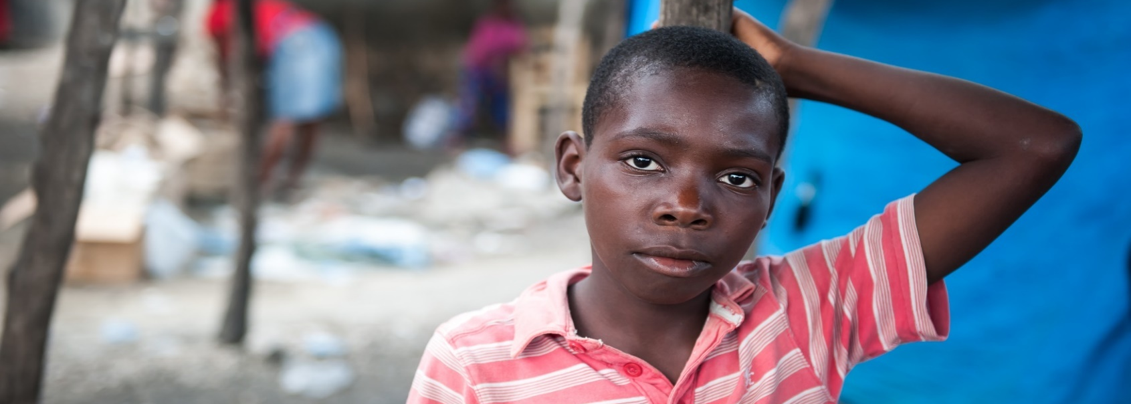

------Sample Sponsorship Letter------
Dear ____________

I hope this letter finds you well. I have some exciting news to share – I have been invited to join a mission trip to the country of Haiti to (describe your specific ministry focus here). I have thought about and prayed about this trip and have talked it over with my family and friends, and really feel that this ministry is something I’d love to be a part of – to make a real difference in the lives of the Haitians we will work with.

We will be working with Global Vision Citadelle Ministries (www.gvcm.org), a Haitian founded ministry that is spreading hope through the gospel and providing food, education, and medical care for many in Haiti, and an orphanage for over 120 children.

The dates of the trip are ____, and I am working on raising ______ - this covers airfare, transportation, food, clean water, and lodging in Haiti, translators, and (a summary of your ministry supplies).

Just knowing that you are behind me in spirit and prayer, I feel you are a significant part of our ministry, and in making this trip happen for me personally. If you would like the opportunity to be a part of this ministry financially, please fill out the enclosed form, making checks out to ______________.

I plan to journal and take pictures, and will send you a newsletter to let you know how this trip went. Thanks again for sharing in this ministry!

Bondye beni ou (that’s Haitian Creole for ‘God Bless You’!)

------Sample Response Form (to include with Sponsorship Letter) ------

For: (Name of trip participant) ___________________________

From: (Name of sponsor) _____________________________

Address: ________________________________________________________________________________

E-mail: _________________________________________

___ I will be praying for you!
___ I’d like to support the team member above financially with my gift of $__________
___ I’d like to support the team financially with my gift of $__________
___We would like to partner with GVCM to help provide hope for Haiti. Enclosed is our gift of $__________.

We understand that the use of our gift is subject to the discretion and control of the mission.

Packing for your trip

One of the most important things you can do to ensure you experience the best possible trip is to plan ahead. International travel can be unpredictable and it always requires flexibility, but you can eliminate many “surprises” by being well prepared.

Packing List

- Passport
- Devotional/journal & pen
- 5-6 changes of clothes (see clothing guidelines below)
- Backpack
- Something to sleep in (cool and modest)
- Comfortable walking shoes
- Twin size sheets & pillow
- Camera
- Light blanket
- Sunglasses
- Towel and washcloth
- Insect repellant
- Watch/Alarm clock (battery)
- Ladies’ personal items
- Rain travel poncho/small umbrella
- Plastic bag for dirty laundry
- Shower shoes (flip flops)
- Toiletries (quantities you need for your stay)
- Swimsuit (see guidelines below)
- Personal spending money
- Wet Ones/Hand sanitizer
- Personal first aid items
- Ear Plugs
- Hat/things to put hair up
- Snacks
- Adequate supply of personal medications
- Toilet paper
- Sunscreen/lip balm with sunscreen
- Small Flashlight and extra batteries
- Bible
- Strong plastic water bottle (with protectable spout)
- Spare glasses (especially if you wear contacts)
- Small sewing kit with safety pins
- Photo of your family (to share with Haitian friends)

Luggage:
The rules for luggage are different for each airline so check with your airline for quantity, size, and weight restrictions. Depending on your airlines' restrictions, we encourage each team member to bring all personal supplies in one piece of luggage and a small backpack (both as a carry-ons); and then check one bag of ministry supplies or items being donated to GVCM.

Dress Code

Our focus in our mission, both at home and abroad, is to spread the gospel to the best of our ability. While we don’t believe or follow many practices of other cultures, we must be sensitive to their beliefs and do our best not to hinder our testimony while serving them. That is the basis for all the guidelines in our dress code. If you have any questions, please contact Sarah Bowers at sarah@gvcm.org and she would be happy to discuss further with you.

- Haiti is very hot and humid most months. We encourage you to wear lightweight clothing.
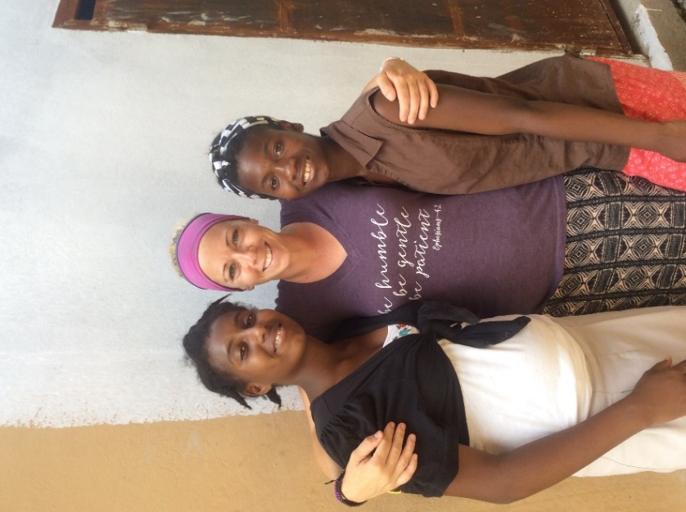
- Scrubs are encouraged for medical professionals on medical trips
- Modest clothing is extremely important.
- Women: No low-neck lines, shoulders should be covered. Dresses or skirts that extend below the knee are requested. However, on the orphanage grounds, it is acceptable to wear pants, capris, or very modest shorts. Modesty includes no tight-hugging, curve-hugging dresses and skirts and please ensure your dresses do not have slits up the side.
- Men: May wear shorts or pants (but no shorts to church services). If you are preaching or teaching, it is proper to wear pants, collared shirt, and closed toe shoes.
- Modest swim wear is required of everyone. Women should wear one-piece swim suits or tankinis.
- In Haiti, body piercings and tattoos are culturally linked to "ladies of the night" and voodoo practices. Therefore, we ask that you help us with the children we are raising, by respecting the cultural differences and removing body piercings and cover (if possible) tattoos. Single ear piercing jewelry is acceptable but all other, please be respectful of the local culture and leave the rest out (preferably at home).
- Fingernail polish is another aspect which has different implications and hidden meanings in the Haitian culture. We advise that you remove any polish in order to strengthen your testimony.

Medications & Vaccinations

- We recommend you contact your healthcare provider to discuss any issues that might affect your specific medical condition.
- Visit www.cdc.gov/travel/caribbean.htm for the latest immunization recommendations
- Prescription medications should be in their original bottles. You can ask your pharmacist to put them in baggies instead of bottles, to save packing room.
  - Recommended: Traveler’s Diarrhea RX, Tylenol/Ibuprofen, tums, pepto bismol, cold or allergy meds, medication for flight/car sickness, Benadryl or other sleep aid to help you sleep if needed, Airborne, hydrocortisone cream for insect bites, antibacterial ointment & band aids, Imodium.
- Team members assume the responsibility and liability for their personal health decisions.
- Especially if you have physical limitations, you must ensure you are physically able to participate in the trip. Some trips can be prohibitive for certain physical conditions, so be sure to ask about the physical demands of your trip.
- Short-term mission trips can be rewarding and life changing, however, they can also be stressful. Please consider factors in your personal life at this time that may distract and prohibit you from fully engaging in team ministry and coping with the emotional and physical challenges of different, and often times, difficult conditions. You will likely have no alone time the entire trip.

Passport & Visa

PASSPORT
- A passport is required to travel to Haiti.
- To obtain a passport, you will need a certified birth certificate (not the hospital record), two passport photos and a driver’s license. It can sometimes take state agencies several weeks to provide a certified birth record if you don’t currently have one.
- You can go to http://www.uspassport123.com for online instruction for a passport
- The cost can range from $85 to $150, depending on when you apply.
- You should allow six to eight weeks for your passport to arrive.
- All travelers should photocopy their passport. Keep one at home and give one to your leader
- Further passport services, where to apply in person and other information is available at:
http://travel.state.gov

VISA
- A visa is not required to travel to Haiti.

THE TRIP

Arriving in Haiti
- On the flight entering Haiti you will be given a green form to complete – it will ask for your personal information as well as details about where you will be staying.
  - Address of GVCM in Haiti:
Route Nat. #3
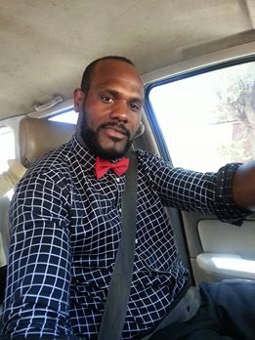
Route Vision Globale, imp Five Oaks
Ledier/Mirebalais, Haiti WI
  - Phone Number of GVCM in Haiti: 772-812-9228
  - Upon your arrival at the airport, you will be directed to customs. Your first stop will be to pay the $10 customs fee (per person).
  - Your next stop will be to head downstairs to pick up your luggage. Once you arrive downstairs, you can go to your left where you will find the luggage carts (which cost $2/cart).
  - From this point, you should be able to find Jean Balthazar, our Missions Coordinator in Haiti waiting for you by the baggage claim. (see picture)
  - Once all luggage has been claimed, you will proceed (following Jean) through the airport to your vehicle.
    - The walk from the airport to the vehicle can be overwhelming for some. There are many individuals asking to help you with your cart. Jean will choose those who will help you with your luggage – do not allow anyone else to take your things. Know this is their occupation and they will be expecting a tip. Nothing more than $2/person is necessary
Jean Balthazar

Cultural Tips and Guidelines

The following may seem harsh, and even heartless, but please, please believe us – we have learned these things the hard way, with multiple people being hurt in the process.

There are cultural considerations and ramifications of some actions that would take pages to explain. We ask for your trust and compliance in the following for the good of our communities, mission, and team members, even though your heart may tell you otherwise at times:
- If a Haitian asks you for something of yours, do not say ‘maybe’. “Maybe” means “yes” to Haitian ears. Do not give away personal items! – You just need to politely say “no”. Any exceptions need to be approved in advance, by GVCM (or your team leader).
- Please do NOT give out money unless you coordinate it with GVCM (or your team leader). Unfortunately, doing this has created somewhat of a ‘begging’ culture, as Haitians know Americans are big-hearted, eager to help, and fairly gullible to sad stories, and so are an easy target (creating a potentially huge safety risk). Again – if there is someone you want to help, go through GVCM staff to do this.
- DO NOT give out: your email address, Facebook info, phone number, or mailing address to Haitian friends. You can communicate with them through GVCM.
- Visitors are in no way permitted to attempt to bring Haitians to the United States, even for a “visit”. This is a complicated and risky endeavor. The mission is here to help and reach Haitians for Christ. It is NOT to be an “escape route” for Haitians to find ways to leave their country.
- Romantic relationships with Haitians, including Haitian staff, cannot be tolerated. Violators may be dismissed to go home early, and may not be accepted back to the mission for future trips.

General Guidelines

- Carry yourself in a way that honors Christ, and be a positive witness.
- When asked to do something, do so with a cheerful attitude.
- Avoid conflict and criticism of each other, leaders, and mission staff.
- Be courteous to those around you.
- Ladies should conduct themselves conservatively and respectfully around the Haitian men.
- Do not leave the area without letting your leader know.
- Do not go for a walk or visit a Haitian home alone. You must take a guide with you.
- Keep your personal area clean always, and clean up after yourself when eating snacks, changing clothes, etc. as you will probably be in close quarters with other team members.
- Conserve water.
- Be mindful of how much food you put on your plate, and many people it needs to feed.
- If you are served something you are not interested in eating please remember to be respectful to the cooking staff as they work very hard to feed teams.
- Please be respectful to those who may go to bed early.

Additional Tips and Helpful Information

WATER
- Please drink only the water that is provided to you. If you are staying at the orphanage, guidelines for water will be explained during your orientation. You should not drink or brush your teeth with any water in Haiti except for designated places at the orphanage, or the water in the big blue jugs when traveling.

FOOD
- While in Haiti, it is best to eat only foods prepared by our cooks. When eating in public places, avoid eating salads or fresh fruit, and eat only food that has been thoroughly cooked. It is good to carry small snacks like granola bars or nuts. Sometimes meals are far apart.

WASH YOUR HANDS
- It is very important that you have hand wipes or sanitizer with you at all times, and that you wash your hands often. Haiti has many germs. Do your best to keep your hands clean and away from your mouth.

LODGING
- The orphanage has bunkhouses, where teams can sleep on bunk beds with a mattress, oftentimes in an air-conditioned room. Housing elsewhere might be bunk beds, or tents, or mattresses on the floor.
- There are restrooms and showers at the orphanage. When you travel, there may not be restrooms or shower water so come prepared to use outhouses. Bring TP and wet wipes.
- Bring comfortable shoes, as you will need to hike at some locations. Rain gear such as a plastic poncho or small umbrella can be a valuable asset.
MONEY
- The amount of money you bring will depend on your desire to buy souvenirs. We recommend bringing $50-$100 in cash for souvenirs and emergency situations. Do not bring bills larger than $20, and we recommend you bring several $1 bills.

WEAR FOOTWEAR AT ALL TIMES
- Microscopic parasites can enter through your feet, so please don’t go barefoot at any time.

INSECTS
- Insecticide sprays or lotions are recommended for repelling mosquitos (which can carry malaria and other diseases); and other bugs such as chiggers (which bite your ankles).

PHOTOGRAPHY
- Ask individuals if it is okay to take their picture. Some Haitians do NOT like their photo to be taken. We need to focus on building relationships, rather than being tourists. When you do take pictures, please be respectful.

COMMUNICATION
- Communication is limited to the United States. (AT&T is one carrier we know that provides a service plan). The mission trip coordinator from the states and/or the GVCM staff will do it’s best to send an e-mail home to confirm that you had a safe arrival. Some teams set up a google group, where one email sent can go out to multiple emails of your designated family & friends. Wi-Fi is usually available at the orphanage.

After Your Trip

Tell your church, family and friends about the work God is doing through the mission and how they can help. We rely on people like you to spread the good news about our ministry. When you return home, please ‘like’ GVCM’s Facebook page, use your God-given talents to write letters, give presentations, share photos, and develop blogs, or a website about your trip.

We also want you to share your trip with us. Upon your return to the states, get in touch with us as we’d love to hear about your trip. Give us an update about your experience, what your team did, people you met, and of course we’d like to add your pictures to our photo album.

Child Sponsorship
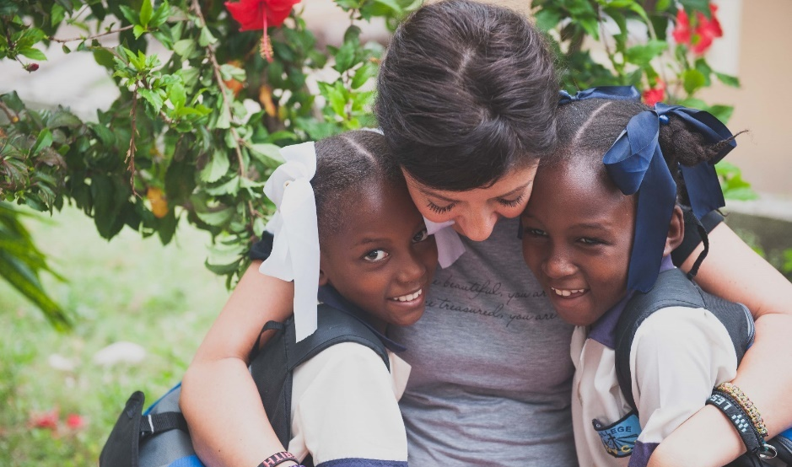

Did a child capture your heart?

A great way to continue your Haiti experience is by sponsoring a child – perhaps that very one. For about $1 per day ($35 per month), your child can get an education, nutritious food, and the knowledge that someone out there cares specially for them.

GVCM works hard to encourage communication between sponsor and child so you can expect to receive and send correspondence, birthday cards etc.

Please email us at info@gvcm.org or visit www.gvcm.org to get more information, and see some of those beautiful faces, just waiting for you!

You’ve visited us – now let us visit you!

We are humbled with your sacrifice of time, energy and finances in order to come visit us in Haiti. Now we want to repay the favor and come visit your church.

Contact us at info@gvcm.org about scheduling a weekend for GVCM to come and visit your church to share all God is doing in and through GVCM.

